

**Worker Comp WC/Auto Accident MVA**

**SCHEDULING:**

**Workers Comp (WC)**:

**With Representative:** Can schedule next available.

**Without Representative:**

Obtain all Claim information

Insurance name

Claim#

Date of Injury/accident

Adjusters name, telephone and ext (if applicable)

**X-rays can be scheduled without authorization.**

**MRI, CT, NM can be scheduled 10 business days out.**

Patient must be advised to call the third party with appointment details and/or you can

transfer the patient. See OCM and Carisk master list to determine which to provide.

**OCM: 1-800-872-2875**

**Carisk: 1-973-451-9415**

**FIRST MANAGED CARE OPTION (FIRST MCO, FMCO) DOES NOT NEED TO SCHEDULE THROUGH OCM**

**Borgata WC can be scheduled for x-rays WITHOUT a Claim number- goes under OCM for insurance carrier**

**Auto Accident (MVA):**

**With Representative:** Can schedule next available.

**Without Representative:**

Obtain all Claim information.

Obtain all Claim information

Insurance name

Claim#

Date of Injury/accident

Adjusters name, telephone and ext (if applicable)

**X-rays can be scheduled without authorization.**

* **Must have Primary Insurance Information**

**MRI, CT, NM can be scheduled 10 business days out.**

* **Carrier Must Fall on Carisk List (*Billing Folder - OP Guide Carisk*)**

**\*\*EXCEPTION* Can be scheduled next available within 10 days of the accident. Day of accident is day**

**1 and includes weekends. All claim/adjuster information must be obtained* \***

Patient must be advised to call the third party with appointment details and/or you can

transfer the patient. See OCM and Carisk master list to determine which to provide.

**OCM: 1-800-872-2875**

**Carisk: 1-973-451-9415**

**One Time Service Agreements:**  ***(Billing Folder – OP Guide One Time Agreement)***

For insurances that require an OTSA, collect all contact information for the insurance and send an

Email to [Billquestions@aminj.com](mailto:Billquestions@aminj.com).

* STATS:
  + Do not require Auth within 10 Days
  + E-mail your PARS & Billing Team involved to insure proper authorization, if not an MRI or CT in order to be billed correctly before exam.

**Example of the format in the Insurance Field In RIS:**

**Motor Vehicle (MV)**

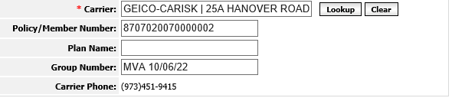

**Workers Comp (WC)**

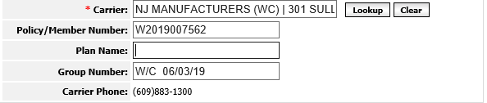

**Example of Correct Format in the Order Field:**

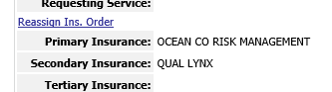

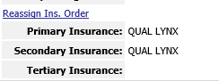

**REGISTERING:**

**MVA**

* Patient needs to complete MVA Paperwork
  + Accident Questionnaire
  + Waiver for AIG
  + Assignment of Benefits (OB)
  + Requires Primary Health Insurance as Secondary Insurance
  + Cc One Call Medical on the Order, if necessary

**WC**

* + Accident Questionnaire
  + Assignment of Benefits (AOB)
  + Cc One Call Medical on the Order, if necessary
  + No Primary Health Insurance required Secondary Insurance
* Receptionist completes Accident Questionnaire with Insurance Field in RIS and have patient complete in its entirety then patient signs.

**OR**

* Receptionist verifies on the form matches what is in the Insurance Field in RIS, when patient completes.

Ensure that correct carrier code and accident date format:

( i.e. ***MVA 01/01/11  or WC 01/01/11***) is being used during registration.

**MVA**

* Patient should present Primary Insurance Card on DOS,  if pt refuses at the front desk, we are still continuing with the study given all MVA claim info is provided.
* X- Rays Only
  + Do Not require authorization for MVA/WC prior to being seen
  + Patient will need to fill out Accident Questionnaire form (attached) in its entirety
  + Please Obtain the Following:
    - Claim #
    - Name of Auto Insurance/Workers Comp Insurance
    - Date of Accident
    - Adjuster Name, Contact Number and Extension
    - Private Medical Insurance Information:
      * If MVA patient, obtain Health Insurance Info if Any
      * IF WC patient, health insurance information is not needed as Workers Comp insurance should be the only insurance for any work-related injuries.
* If WC then patients employers name i.e. Walmart, Borgata etc
* If MVA/WC payer is listed under OCM then we will need to obtain OCM scheduling authorization form but these patients should never be turned away. Our front desk team/FD Leads can call OCM **(800) 872-2875**  to obtain the scheduling auth form after registration .

* If you have any questions, you can always reach out to our PARS or Billing Team for further assistance.